Victoria Junior College
H2 Mathematics (9740) – 2012 Preliminary Examinations Paper 2
This list of common mistakes and comments are compiled to maximise your learning through the mistakes made. Do not miss the opportunity. Go through all the details carefully so that you will not make the same mistakes in the A level exams.
- (i) The locus of point P is the half-line from (1, 2) (excluding it),
inclined at an angle of  with the positive real axis.
(ii)

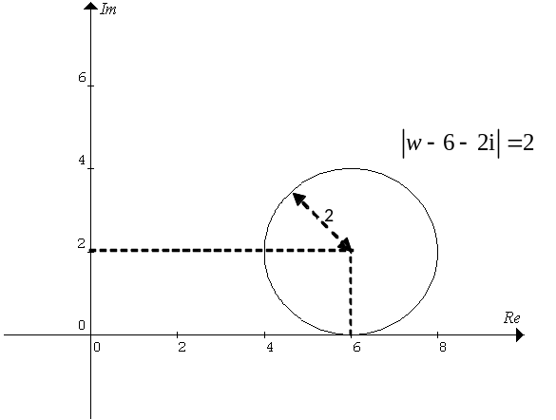
(iii)

- (i) 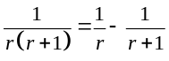
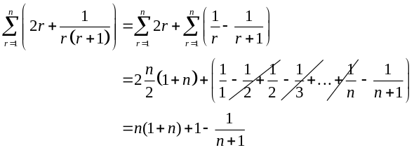
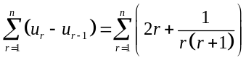
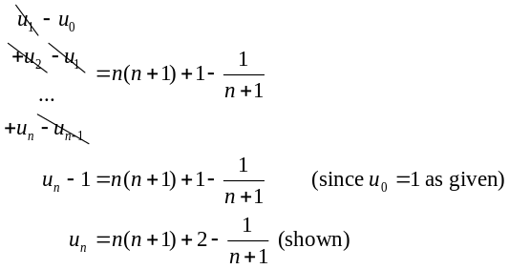

(1, 2)
π/6
• (1, 6)
|z – 1 – 6i|_{min}
|z – 1 – 6i|_{min}
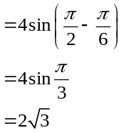

4

Locus of P meets locus of Q more than once if 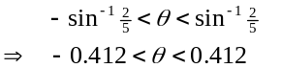

2
2
5
|w – 6 – 2i| = 2

(1, 2)
θ

(ii)

Alternative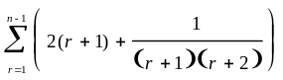
=
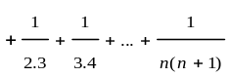
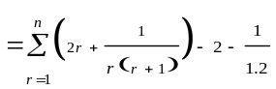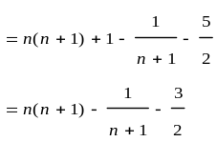

i) Since replacing x with –x results in the same equation, the
graph is symmetrical about the y-axis.
(ii)

(iii) The line
is vertical, so at x = k,
is undefined.

When

Hence,
.
(iv) When
Equation of tangent :

Solving equations of the tangent
and the curve simultaneously, we get

(rejected as this gives the previous point)
or
(3 s.f.)

(iii)

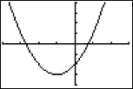

(i)

So the equation of the line l is
(ii) Given that the system of equations of the 3 planes has infinitely
many solutions, it implies that line l lies on the plane p₃.
So
for all real values of

This is satisfied when a = 4 and therefore b = 18.
OR
.

(iii) plane is perpendicular to p₁ and p₂ ⇒ it is perpendicular to l.
∴normal to the plane is
.
Equation of the plane is

(iv) p_{1,} p₂ and p₄ have no common point:

p₁
p₂

examples of p₄
line l
line m
(3, 4, 1)

•
m is parallel to l.
∴distance between m and l = distance from (3,4,1) to l.
B(3,4,1)
m •
l •
A(5,1,0)
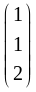
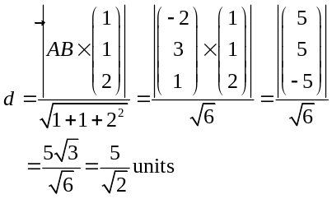
d
(i) Let
cm be the population mean increase in heights of orchid
plants in the nursery.

As n = 55 is large, by Central Limit Theorem,
is approximately
normal. ∴no assumption about the increase in heights is needed.

(ii) Level of significance: 5%
Test-statistic: When H₀ is true,
Distribution of Z

∴
(iii) There is a 5% probability of the test concluding that there is a
significant improvement in the mean increase in heights of
orchids when there is not.

6 (a) Due to time and resource constraints, the committee would
prefer to poll a sample instead of all members.

Obtain a numbered name list of the club members. Use a random
number generator to choose an integer from 1 to 10. Choose the
member corresponding to that number on the name list followed by
every 10th member subsequently until 100 members are selected.

If there are cyclical patterns in the name list, the survey might be
biased.

(b) Case 1: Adam & Bernice are together :
Case 2: Adam & Bernice separated by exactly 1 person:

Required number of ways =

Let X be the number of free gifts claimed per week.
Let n denote the number of gifts kept in stock at the start of
the week. For
, from the GC:
nP(X ≤ n)120.9362130.96582

0
1.6449
0.05
∴the least number of free gifts
needed is 13.
0.95
Rejection Region:

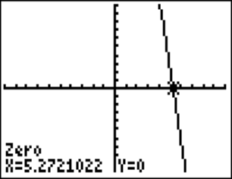
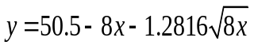
7. (ii) Let Y be the number of free gifts claimed in m weeks.

*If 8m > 10,
.
Standardising, we have
.

∴largest integer value of m = 5.
*for Normal approximation to Poisson
distribution, m > 5/4.

Let X and Y denote the waiting times, in minutes, at the fitting
room for a man and a woman respectively. Given
E(X) = 4.2, Var(X) = 1.6² & E(Y) = 8.5, Var(Y) = 2.2²
Let
. By Central Limit Theorem,

For
,

∴least integer value of k = 9

Given X ~ N(4.2, 1.6²), Y ~ N(8.5, 2.2²) ,

Assumption: The waiting times for the 6 men and 1 woman are
all independent of one another.

Let W be the number of woman out of 4 with waiting time
more than 8.5mins. W ~ B(4, 0.5)
P(W ≥ 3) = 1 – P(W ≤ 2) = 0.3125

0
1.2816
0.10
Z
0.10
8.8987
0.90
0.90
9. (i)

(ii) r = 0.971 (to 3 s.f.)
The magnitude is close to 1, suggesting a strong positive linear
correlation between the daily temperature and number of ice
cream cones sold.
(iii)
(a) Using the regression line of y on x, y = -934.47+32.753x ,
when x = 33.3, y = 156 (to 3 s.f.).
Since x = 33.3 is within the data range of x and there is a strong
linear correlation between x and y, this estimate is a reliable one.
(b) Yes, the owner has reasons to suspect dishonesty. The large
difference between the reported value and the reliable estimate
suggests a high possibility of dishonest reporting.

(iv) For the data ln y and x, r = 0.989 (3s.f).
Since this value is closer to 1 compared to the earlier value of
0.971, ln y = a + bx is the better model.
Using
and let initial values be x₀, y₀:

Percentage increase in number of ice cream cones

(a) n = 6:
(i)

x / ̊ C
y
Q10 (ii)

(iii)

(b) n-sided dice

(iii)P(there are 4 trials | score is 3) =
=
=

(b)P(score is 3 on 1st trial) =
=

P(score is 3) =
=
=
So a = 4 and b = 1

n
90.05556100.04444
From the GC, the greatest number of die faces is 9.

9.46
-8.46
∴greatest n = 9
Alternative:
Sketch 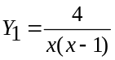
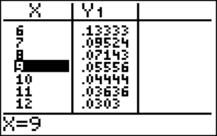
From GC, greatest n = 9
y =n² – n - 80
n

